Technical Design Document

## Basic Components/Modules:

1. Database – Sqlite3
2. API Layer – Flask API (Python)
3. Communication Protocol – HTTP
4. API logic and Code base – Python
5. ORM tool – SQLalchemy (Python)

## API Endpoints:

|  |  |  |  |
| --- | --- | --- | --- |
| Endpoint | HTTP Method | CRUD Method | Result |
| /api/phonebook/ | GET | READ | Get all phone book entries |
| /api/phonebook/add | POST | CREATE | Create entry in phone book |
| /api/ phonebook/search/:surname | GET | READ | Get phone book by sur name |
| /api/phonebook/update/:surname,:firstname | PUT | UPDATE | Update entry in phone book |
| /api/phonebook/remove/:surname,:firstname | DELETE | DELETE | Delete entry in phone book |

## Design Diagram:

## Database Schema:

DB Name: phonebook.db

CREATE TABLE "phonebook" (

"_id" INTEGER NOT NULL,

"sur_name" VARCHAR(32),

"first_name" VARCHAR(32),

"phone_number" INTEGER,

"creationDate" DATETIME,

"updatedDate" DATETIME,

"address" VARCHAR(255),

PRIMARY KEY("_id")

);

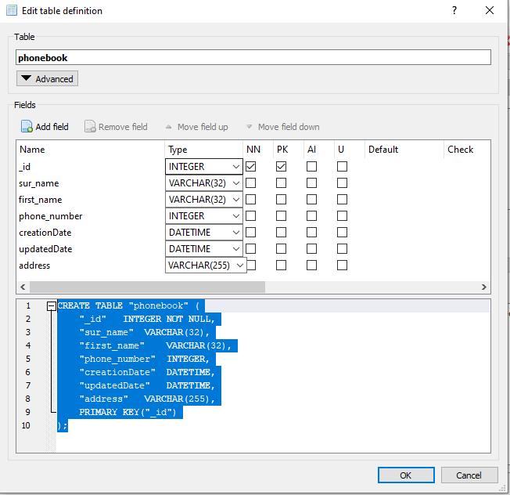

## API Examples:

|  |  |  |
| --- | --- | --- |
| Endpoint | HTTP Method | Sample Request |
| /api/phonebook/ | GET | <http://127.0.0.1:5000/api/phonebook> |
| /api/phonebook/add | POST | http://127.0.0.1:5000/api/phonebook/add?sur_name="Suman"&first_name="H"&phone_number=4444444444 |
| /api/ phonebook/search/:surname | GET | <http://127.0.0.1:5000/api/phonebook/search/Patel> |
| /api/phonebook/update/:surname,:firstname | PUT | http://127.0.0.1:5000/api/phonebook/update/abc/xyz/sur_name=Suman&first_name=H&phone_number=4444444444 |
| /api/phonebook/remove/:surname,:firstname | DELETE | http://127.0.0.1:5000/api/phonebook/remove/abc/xyz/ |